|  |
| --- |
|  |
| Sigma-X User’s Guide |
|  |
|  |
| **Prepared by Milan Zlatkovic (**[**mzlatkov@uwyo.edu**](mailto:mzlatkov@uwyo.edu)**)** |
| **Last Revised: March 29, 2021** |

|  |
| --- |
| Copyright (C) 2021 Milan Zlatkovic.  Permission is granted to copy, distribute and/or modify this document under the terms of the GNU Free Documentation License, Version 1.3 or any later version published by the Free Software Foundation; with no Invariant Sections, no Front-Cover Texts, and no Back-Cover Texts. A copy of the license is included in [www.gnu.org/licenses/fdl.html](http://www.gnu.org/licenses/fdl.html). |

**Please feel free to send any questions, feedback, and corrections to Milan Zlatkovic (**[**mzlatkov@uwyo.edu**](mailto:mzlatkov@uwyo.edu)**) or Dr. Xuesong Zhou (**[**xzhou99@gmail.com**](mailto:xzhou99@gmail.com)**)**

## Sigma-X Application for Traffic Signal Timing

The accompanying Sigma-X Excel spreadsheet represents a computational engine for estimating signalized intersections operation. It is relying on the HCM 2010 methodology for signalized intersection analysis and the HCM Quick Estimation Method (QEM), but it is also using other methodologies for computing parameters of signalized intersections (as described in the Signal Timing Manual (STM), 2008 and 2015 editions). The data flow of the Sigma-X computational engine is shown in Figure 1.

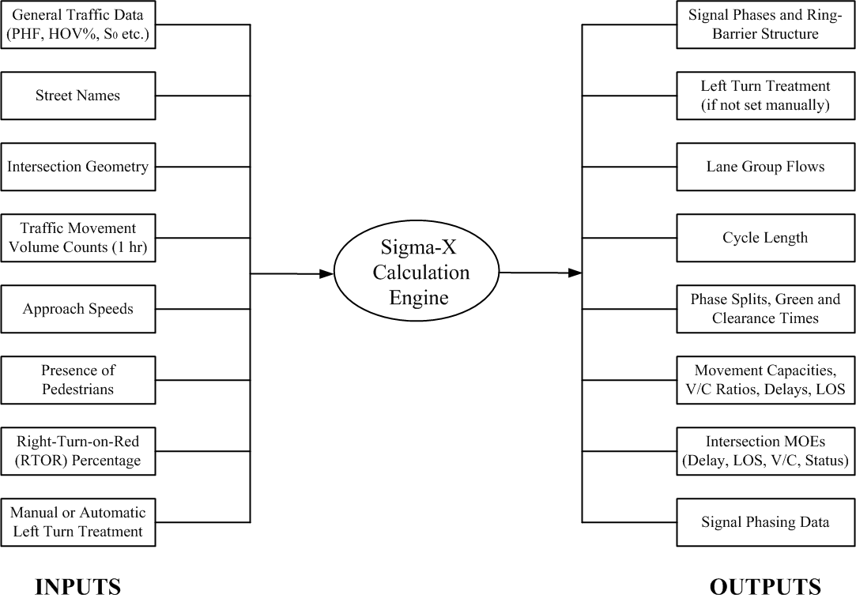

**Figure 1. Sigma-X Data Flow**

## Methodology

The methodology of the Sigma-X application is given by sections, and they are defined as follows (different tabs in the spreadsheet):

* Input sheet – data input section; this is the only section where the user needs to input intersection data if the spreadsheet is used as a stand-alone application
* Phase designation – assigning phases to intersection movements, determining left turn treatment and defining ring-barrier structure
* Lane volumes – calculation of lane volumes (HCM 2010 Chapter 31)
* Phase calculation – calculation of the cycle length, green time (splits) allocations, movement capacities, V/C ratios, and Levels of Service (LOS)
* Phasing – calculate phasing data for correct export to Synchro
* Summary sheet – output sheet with calculation results

The **Input sheet** is the only section where the user is asked to enter intersection data. The following inputs are needed:

* Value of time (VOT) and truck percentages – optional. This entry is used with some applications which estimate user costs for intersections. If truck percentage is not known, it can be set to 3%.
* Street names – optional.
* Intersection lane configuration – required (number of lanes for each approach and each movement).
* Turning volumes for each movement – required.
* Approach through speeds – important if these speeds are greater than 45 mph, since this is one of the requirements for protected-only left turn treatments.
* Presence of pedestrians – select option (Yes/No) from the drop-down menu for each approach. If pedestrians are present, pedestrian timing will be included in minimum splits and cycle calculation. For urban intersection, this option should generally be activated.
* Pedestrian and bicycle volumes – optional. This is an option used with some applications where pedestrian and bicycle delays and costs are estimated.
* Transit frequency – optional. It is used with some applications where transit delays are estimated.
* Manual selection of left turn treatment – if used as a stand-alone version and field data regarding left turn treatment are known, this entry allows for a manual selection of left turn treatment. If activated, this option will allow left turn treatment for each approach to be selected from the drop-down menu. The options are: Protected, Permitted, Protected + permitted, or blank. This entry will override the automatic designation of left turn treatments.
* Ideal saturation flow rate – by default, this value is 1900 vphpl; needed only if the user has calibrated saturation flow rate for local conditions.
* Peak Hour Factor (PHF) – if known, it can be entered in this field. Otherwise, it can be set to the value of 1.0.
* Percentage of heavy vehicles (HGV %) – this value is entered in cell B4. If not know, can be set to 3%.
* Lost time per phase – 4s is the default value. Should be changed only if warranted by field data collection.
* Area type – CBD or Other, selected from the drop down menu.
* Minimum and maximum cycle – values used by the local agencies. The default values are 40s and 150s.
* Pedestrian speed – the default value is 3.5 fps. It is used to determine the pedestrian clearance times for signalized crossings. Can be change if field values are known.

After the input values are defined, the user should not change any other values in other sheets. The layout of the Input Sheet is shown in Figure 2.

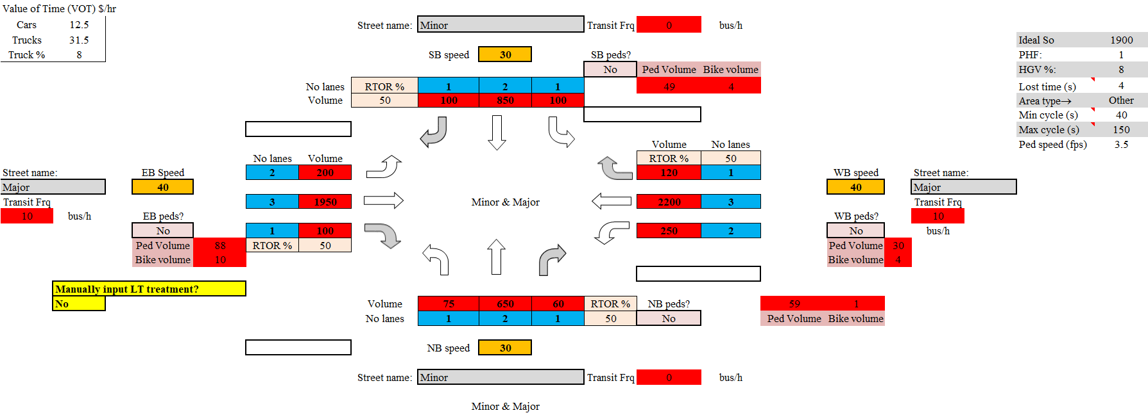

**Figure 2. Input Sheet**

The **Phase Designation** sheet, shown in Figure 3, determines the major street (NS or EW), defines phases for each movement, and determines the left turn treatment based on the criteria defined in the HCM and STM (Protected only, Permitted only, or Protected + permitted). If the left turn treatment is manually selected in the Input sheet, this selection will be implemented, and the automatic designation overridden. In the case of a 3-leg intersection, the left turn is treated as permitted (the through phase is shown). For phase numbering, the Utah Department of Transportation (UDOT) standard is used: if NS is the major movement, the NB through movement is phase 2; if EW is the major movement, the WB through movement is phase 2. Once the phases and left turn treatments are known, the program defines the standard dual ring-barrier structure for the given case, which is used in follow-up calculations.

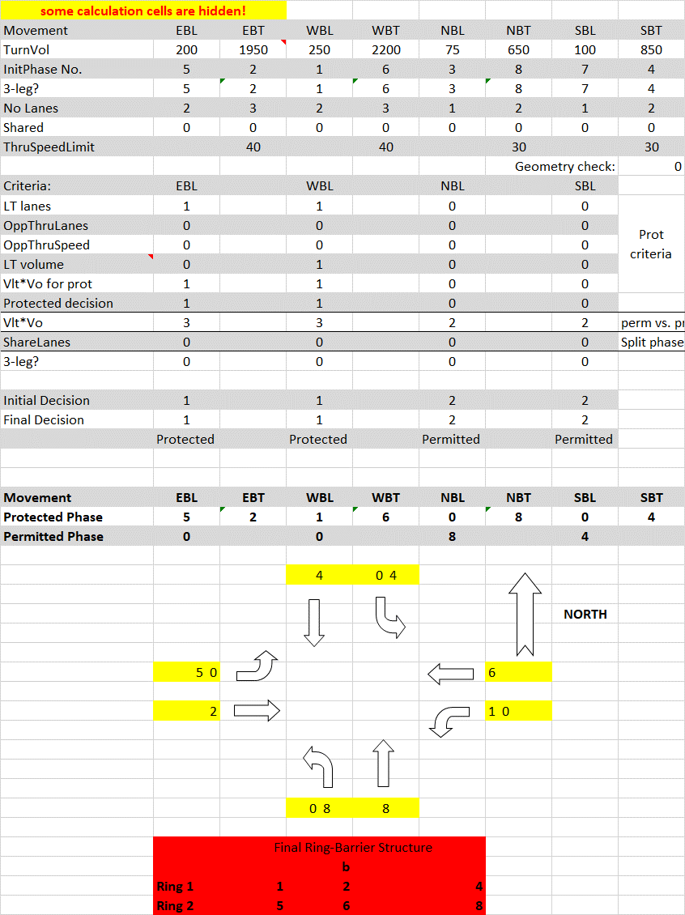

**Figure 3. Phase Designation Sheet**

The **Lane volumes** sheet, shown in Figure 4, calculates critical lane volumes for each intersection approach. It follows the methodology defined in the HCM 2010, Chapter 31. The computed lane volumes are later used in cycle length calculation.

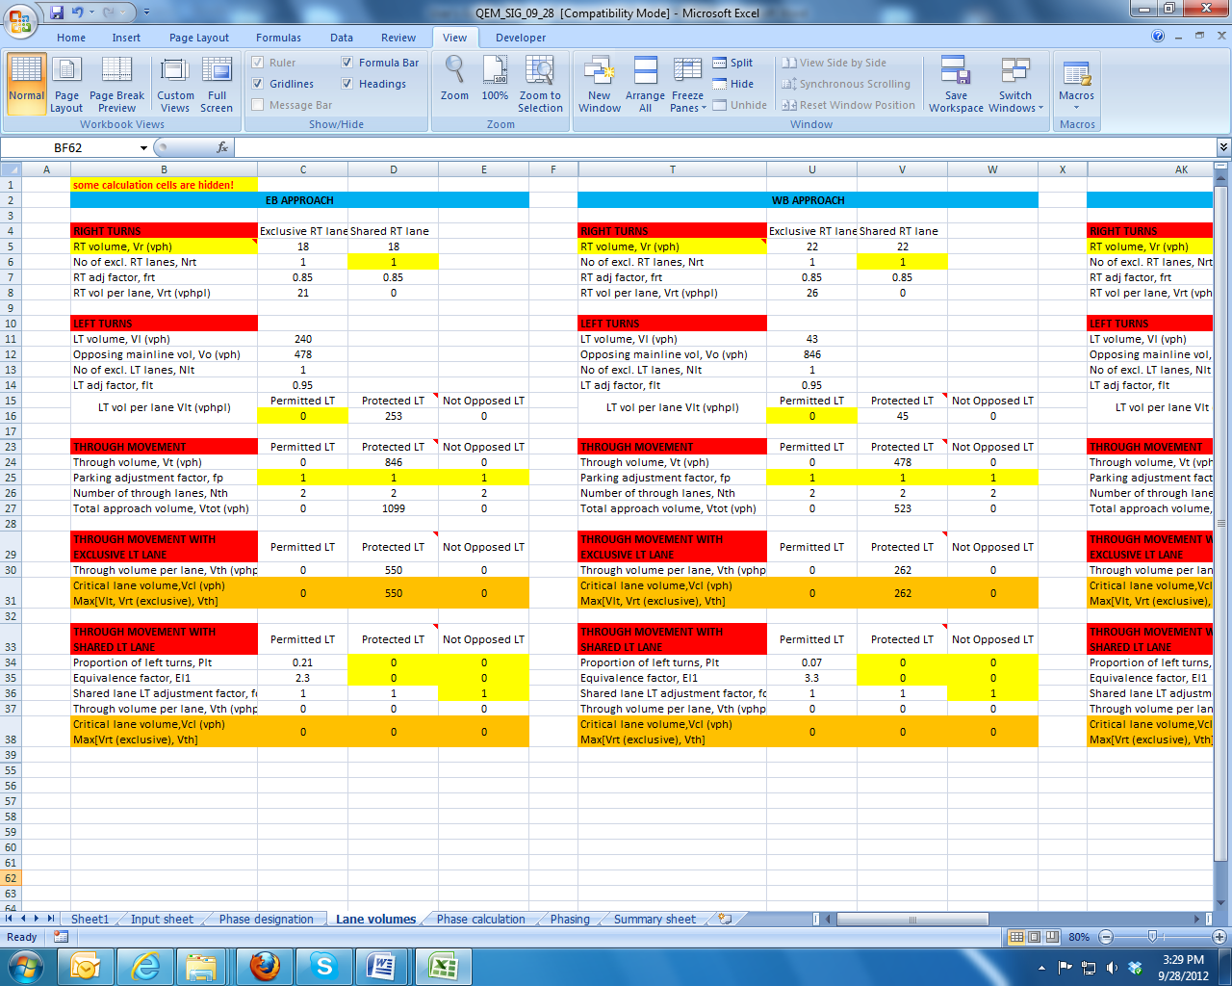

**Figure 4. Phase Designation Sheet**

The **Phase calculation** sheet performs calculations of all signal control parameters. It is using inputs defined by the user, and outputs from the previous steps. It is using the critical movement methodology for cycle length calculations. The cycle length calculation is in this version limited to 10 second increments, in the range between 40 seconds (Cmin) and 150 seconds (Cmax). Once the cycle length is determined, the following steps are implemented in parameters calculation:

1. For the given cycle length, phasing and turning volumes, the minimum and maximum phase green times are determined.
2. The corresponding splits (green time + exchange interval) are assigned to each phase in the ring-barrier structure.
3. The splits are recalculated for each phase based on the cycle length and the critical ring split summation.
4. The splits are recalculated again for each barrier, following the critical barrier split summation. This step ensures the simultaneous barrier crossing and prevents phase conflicts.
5. The calculated splits are compared to the minimum splits (see Phasing), and are reassigned if necessary.
6. When the phase splits are know, the HCM procedure is followed to calculate movement capacities, V/C ratios, control delays and LOS.

This section goes beyond the typical QE methodology, since it gives realistic signal timing parameters common in all North American ring-barrier controllers.

The cycle length can also be optimized using the Macro function. The optimization is performed in such a way to minimize the total intersection delay. The Phase Calculation sheet is shown in Figure 5.

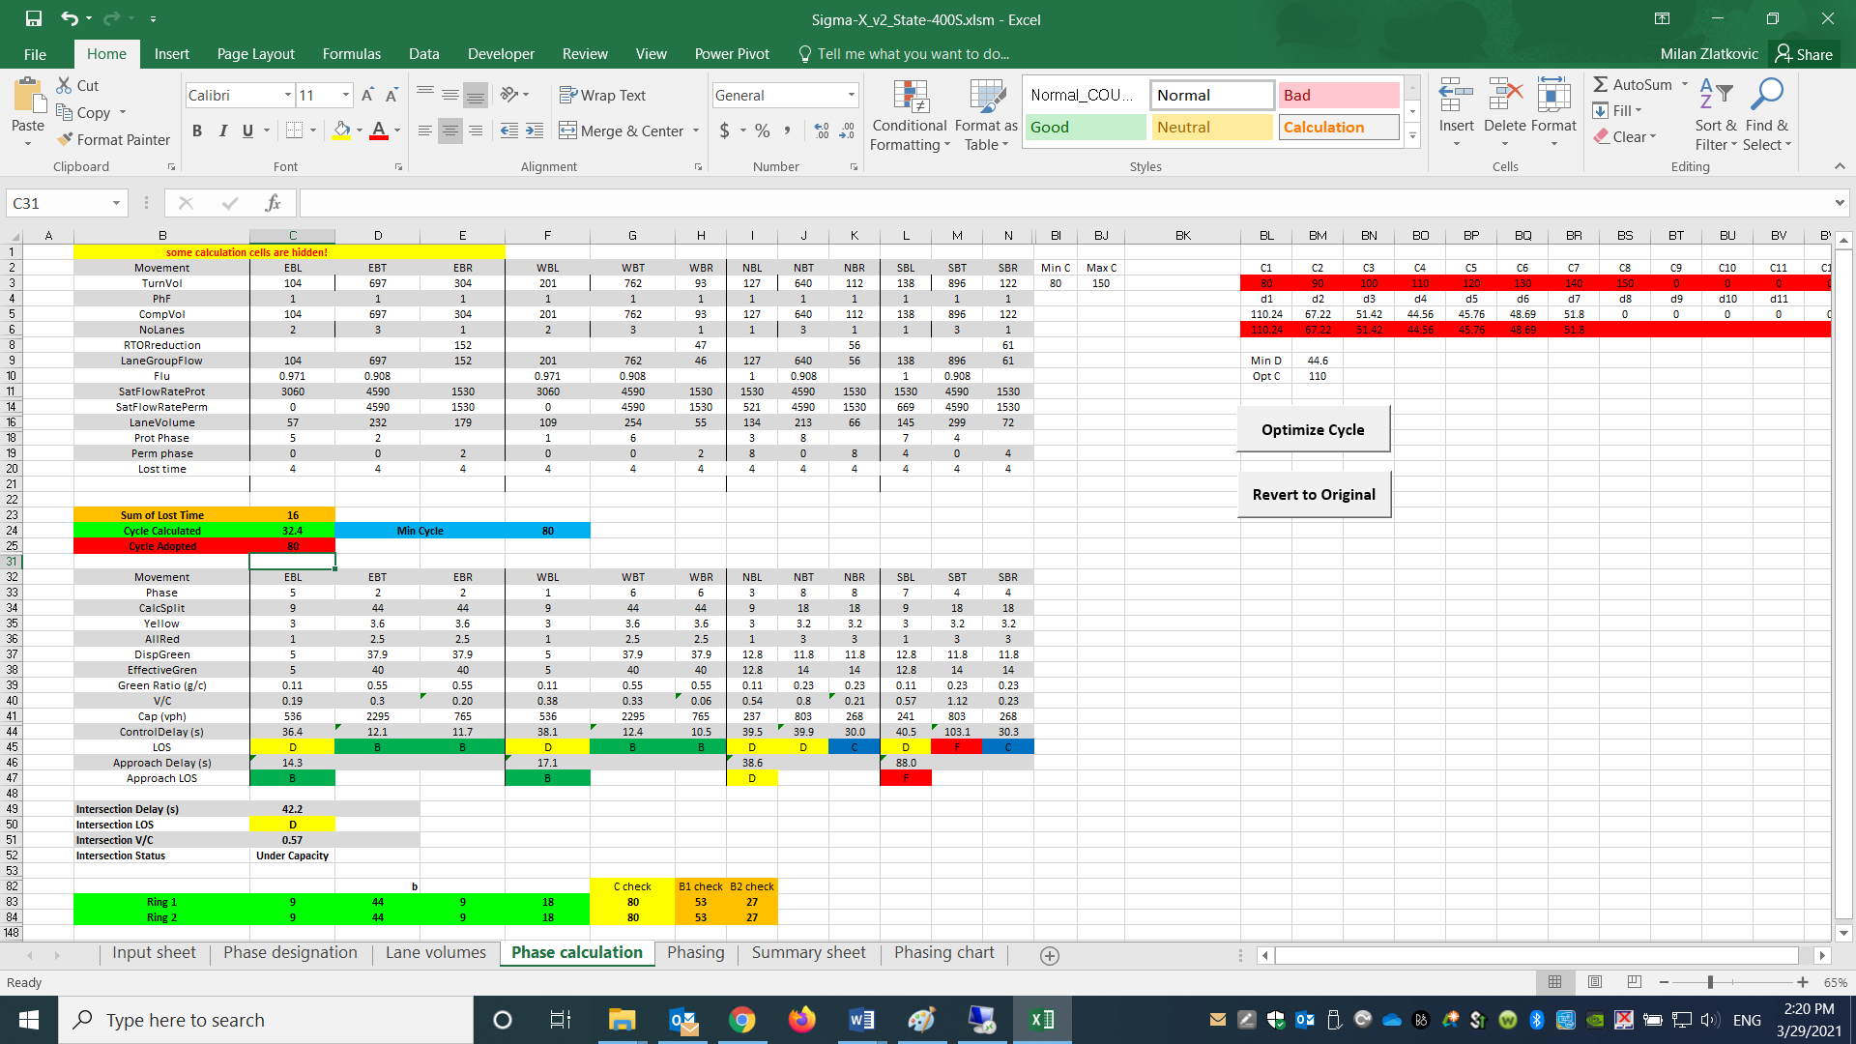

**Figure 5. Phase Calculation Sheet**

The **Phasing** sheet, shown in Figure 6, calculates all the phasing data required by Synchro for an error-free analysis. It is using default tables from the STM for different parameters. The parameters calculated in this sheet are:

|  |  |  |
| --- | --- | --- |
| * Minimum green | * Minimum phase recall | * Phase end time |
| * Maximum green | * Walk time | * Phase yield time |
| * Vehicle extension | * Don’t walk time | * Phase yield for type 170 controllers |
| * Time before reduce | * Pedestrian recalls | * Local start time |
| * Time to reduce | * Minimum split | * Local yield time |
| * Minimum gap | * Dual entry | * Local yield time for type 170 controllers |
| * Yellow time | * Max time call inhibition |  |
| * All red time | * Phase start time |  |

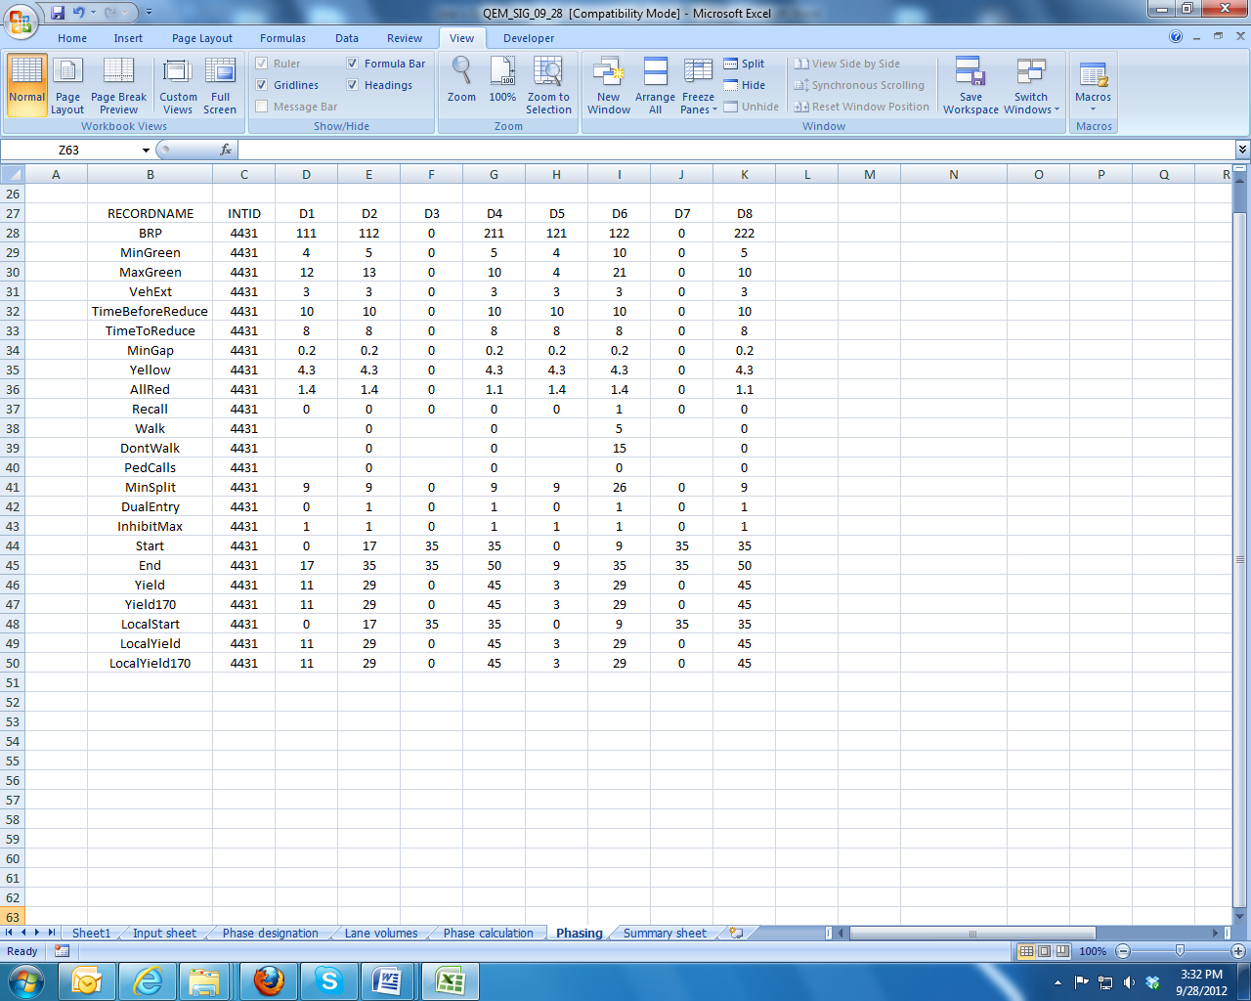

**Figure 6. Phasing Sheet**

The **Summary sheet** gives all the main outputs from previous steps in is a user-friendly graphical representation. The following parameters are shown:

* Turning volumes (vph)
* Phase designations
* Split durations (s)
* Movement capacities (vph)
* V/C ratios
* Control delays (s)
* Intersection LOS

The layout of the Summary sheet is shown in Figure 7.

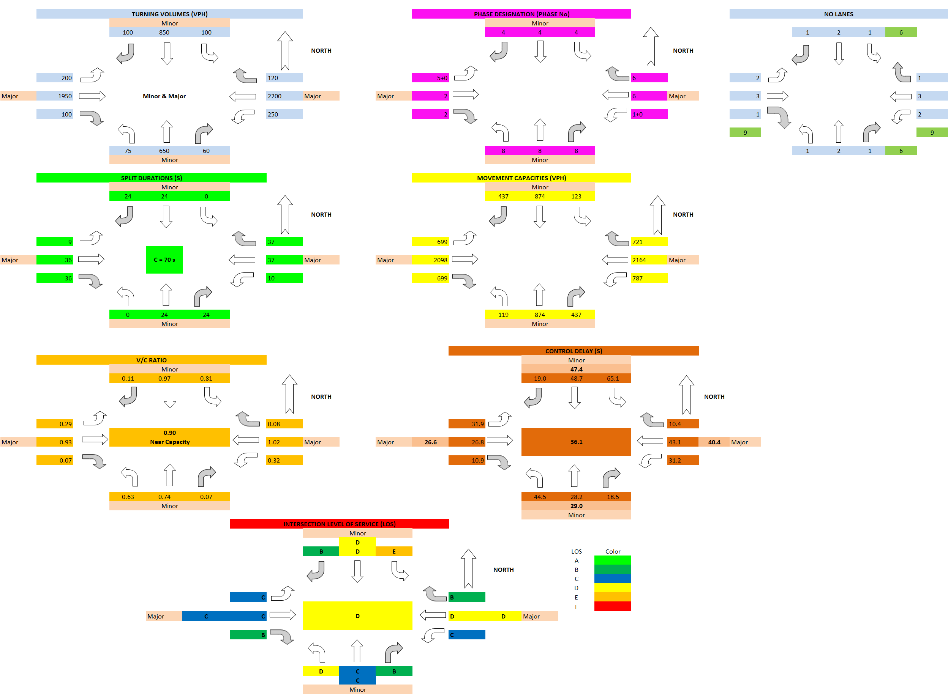

**Figure 7. Summary Sheet**

## Example 1: Typical 4-leg Intersection

The first example is provided for the intersection of State Street and 400 S in Salt Lake City, UT. Both approaches on State Street have three lanes for through, one lane for left turns, and separate right turn lanes. The speed limit along State Street is 30 mph. Both approaches on 400 S have three lanes for through movements, two left turn lanes, and a separate right turn lane. The speed limit on 400 S is 35 mph. Traffic data inputs are defined for the PM peak hour, 5:00 – 6:00 pm. The peak hour factor is 0.92, and the percentage of heavy vehicles is 2%. Pedestrian crossings are present at all approaches. The intersection layout is given in Figure E1-1.

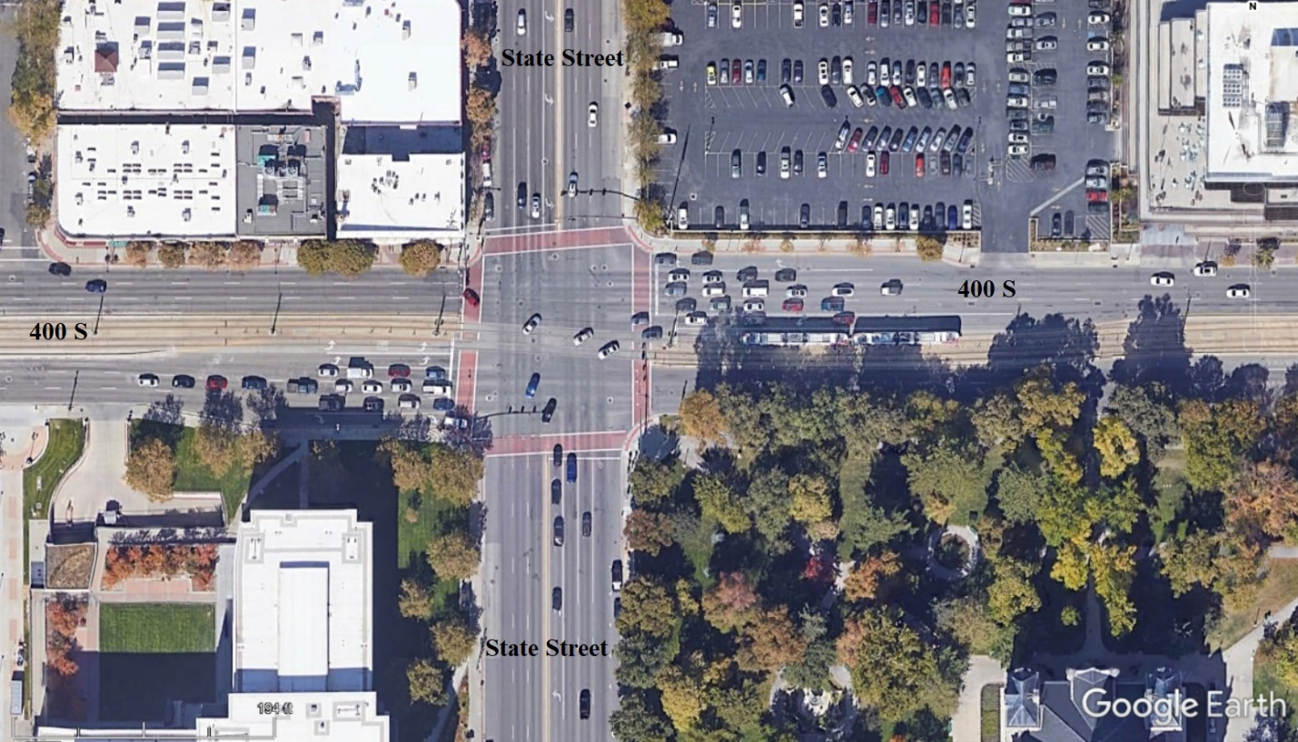

**Figure E1-1: State Street and 400 S Intersection, Salt Lake City. Source: Google Earth**

These data are used as inputs for Sigma-X. Figure E1-2 shows the Sigma-X input data configuration. Manual selection for left turn treatment is disabled in this case.

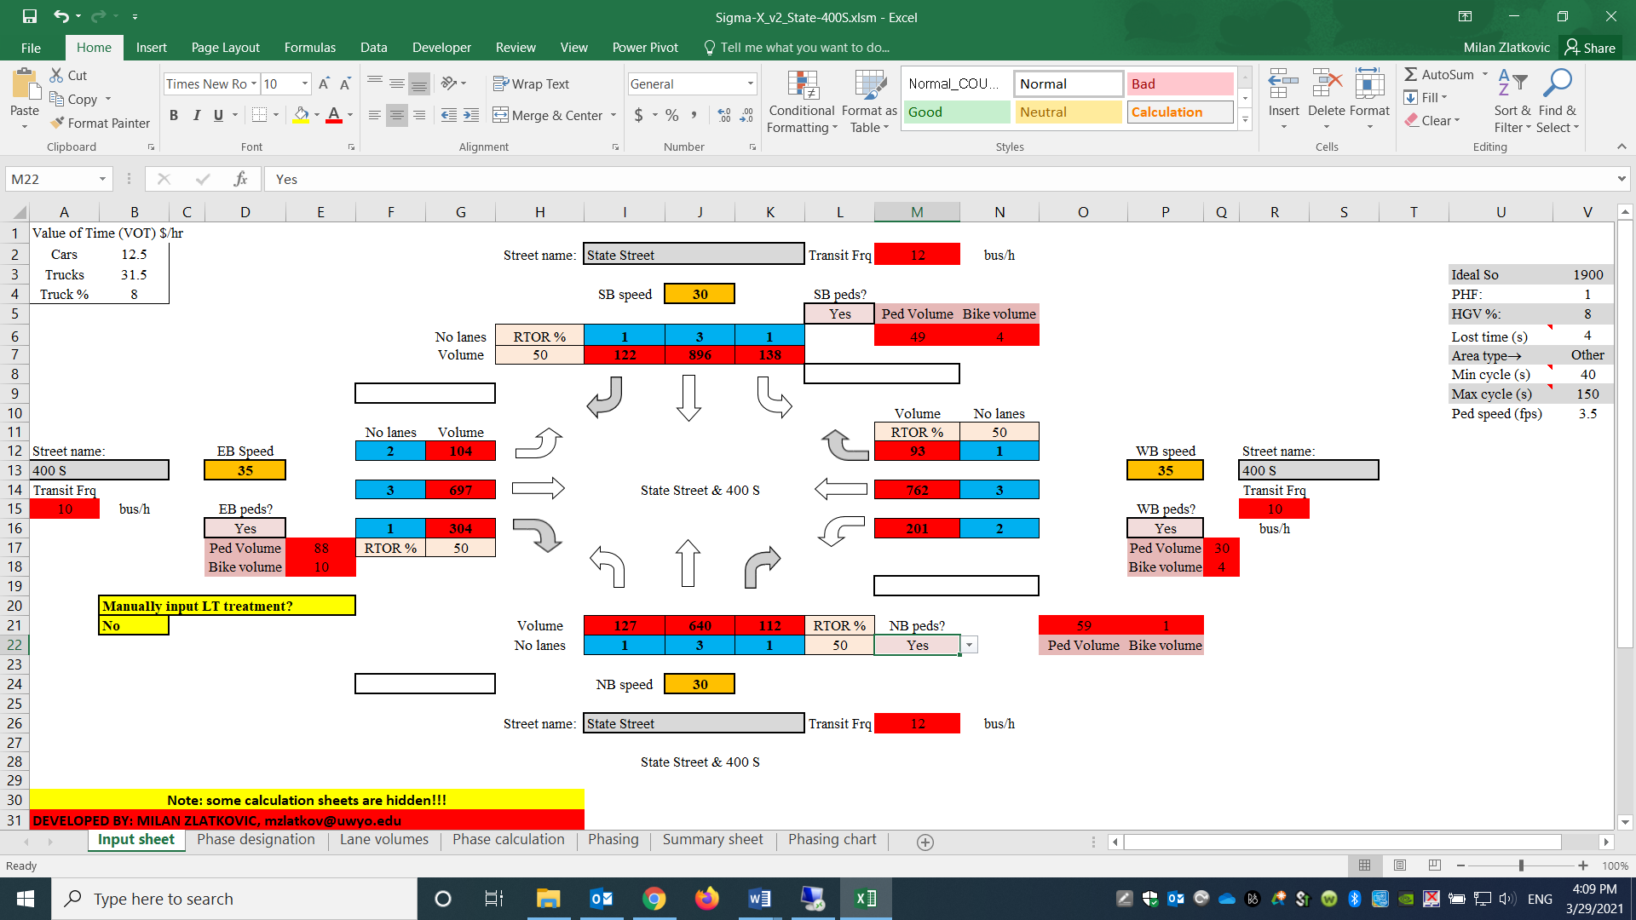

**Figure E1-2. Sigma-X Inputs for State Street and 400 S Intersection**

Based on the given inputs, Sigma-X yields the results as shown in Figure E1-3:

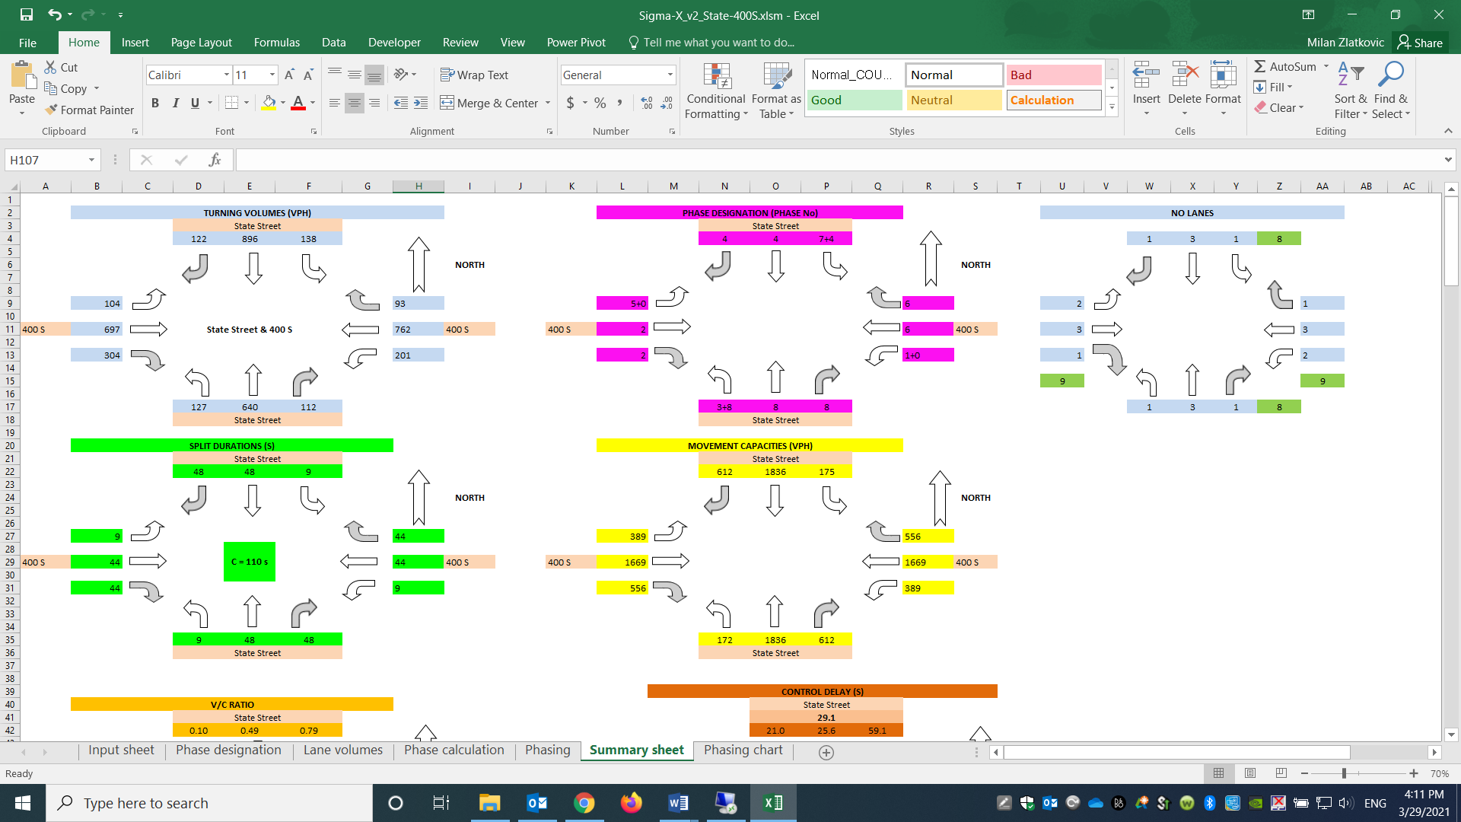

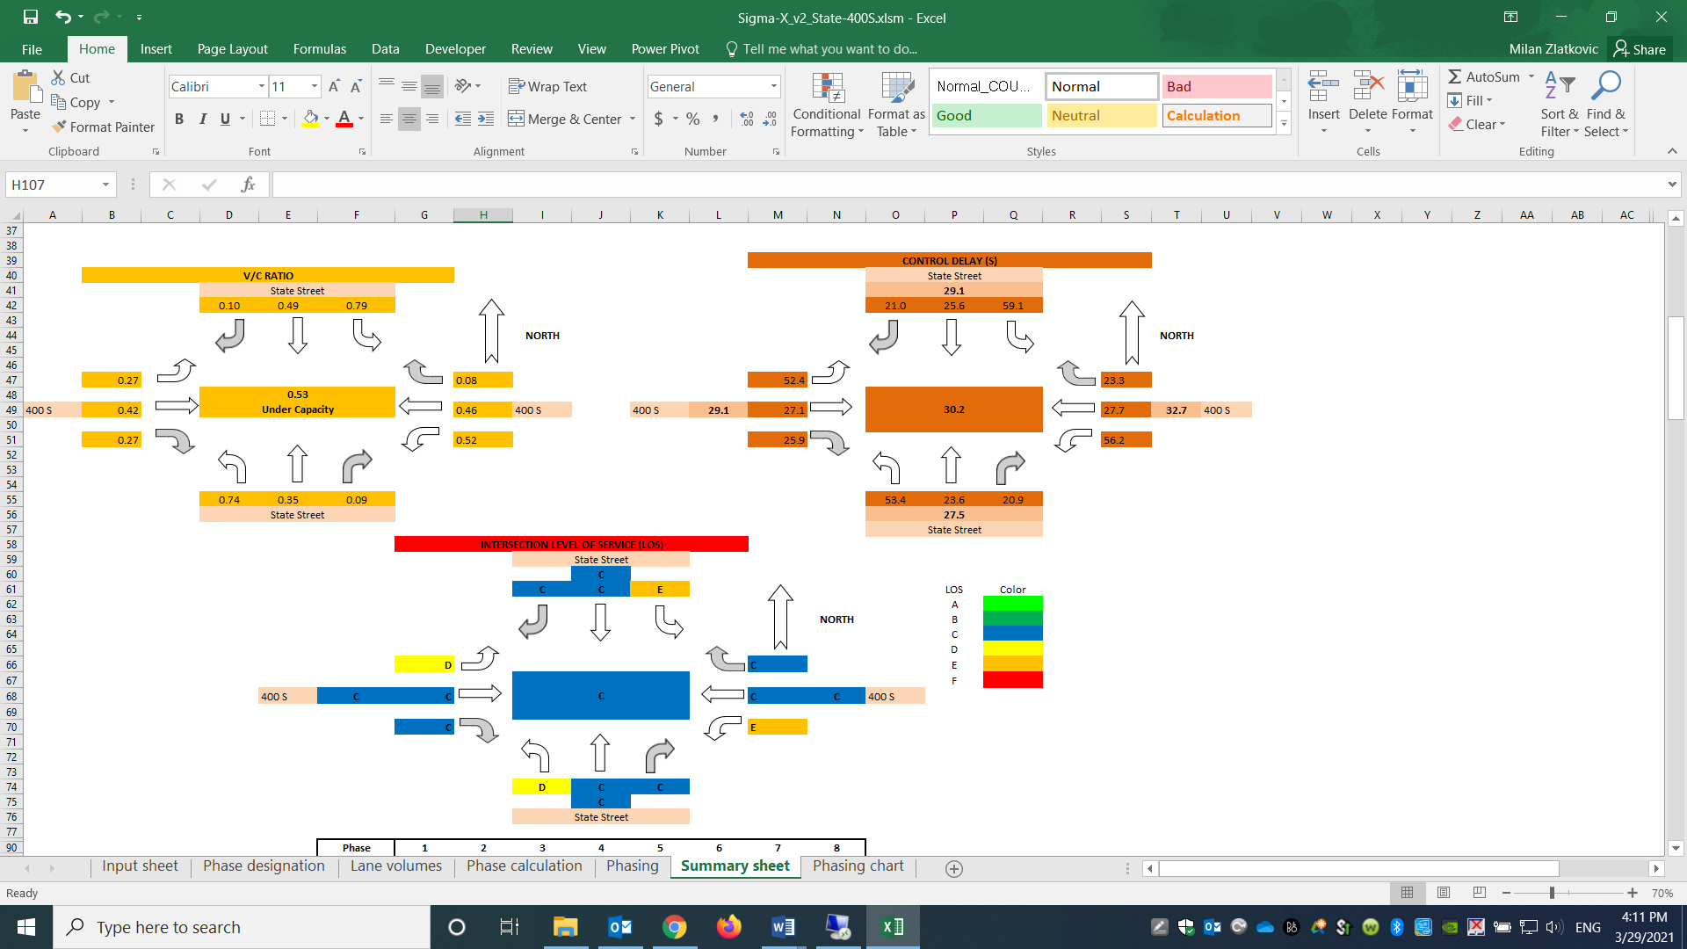

**Figure E1-3. Sigma-X Results for State Street and 400 S Intersection**

Sigma-X assigns protected + permitted left turns to NB and SB movements along State Street, and protected only left turns for EB and WB movements along 400 S. This is the same as the intersection operates in the field. The cycle length is estimated to 110 s, intersection delay is 30.2 s/veh, and LOS is C.

In order to find if there is a more optimal solution, one can use the “Optimize Cycle” function in the Phase Calculation sheet. In this particular case, the computed cycle length is already optimal, so the solution would not change.

## Example 2: 3-leg Intersection

The second example is provided for the intersection of 5200 W and 3500 S in West Valley City, UT, which is a 3-leg intersection with no SB approach. Both approaches on 3500 W have two lanes for through movements. The WB approach on 3500 S has a separate left turn lane, while the EB approach shares the rightmost through lane with right turns. 5200 W NB approach has separate lanes for left and right turn movements. The speed limit along 3500 W is 40 mph, while the speed limit on 5200 W is 35 mph. Traffic inputs for this intersection are for the PM peak hour, 5:00 – 6:00 pm. The peak hour factor is 0.92, and the percentage of heavy vehicles is 2%. There is no WB pedestrian crossing. The intersection layout is given in Figure E2-1.

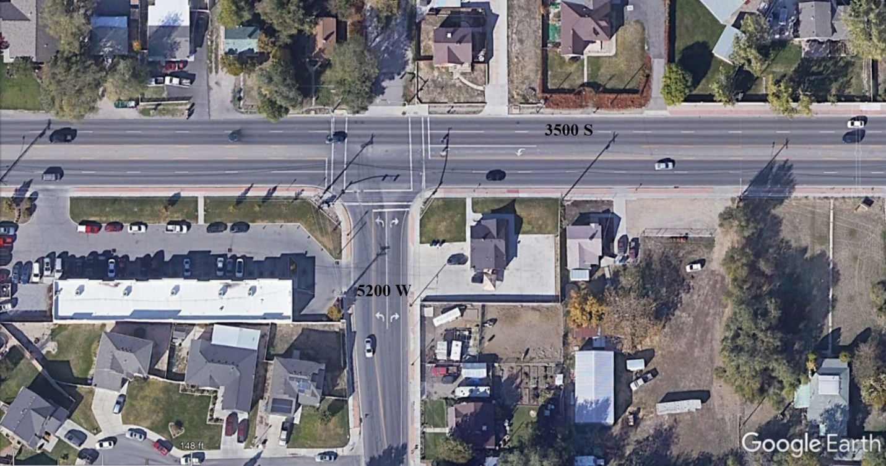

**Figure E2-1. 5200 W 3500 S Intersection Layout**

These data are used as inputs for Sigma-X. Figure E2-2 shows the Sigma-X input data configuration.

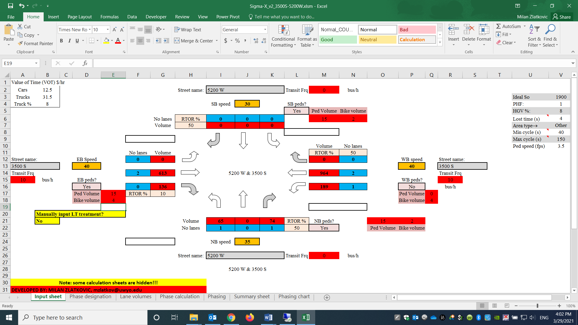

**Figure E2-2. Sigma-X Inputs for 5200 W and 3500 S Intersection**

Based on the given inputs, the Sigma-X yields the results given in Figure E2-3:

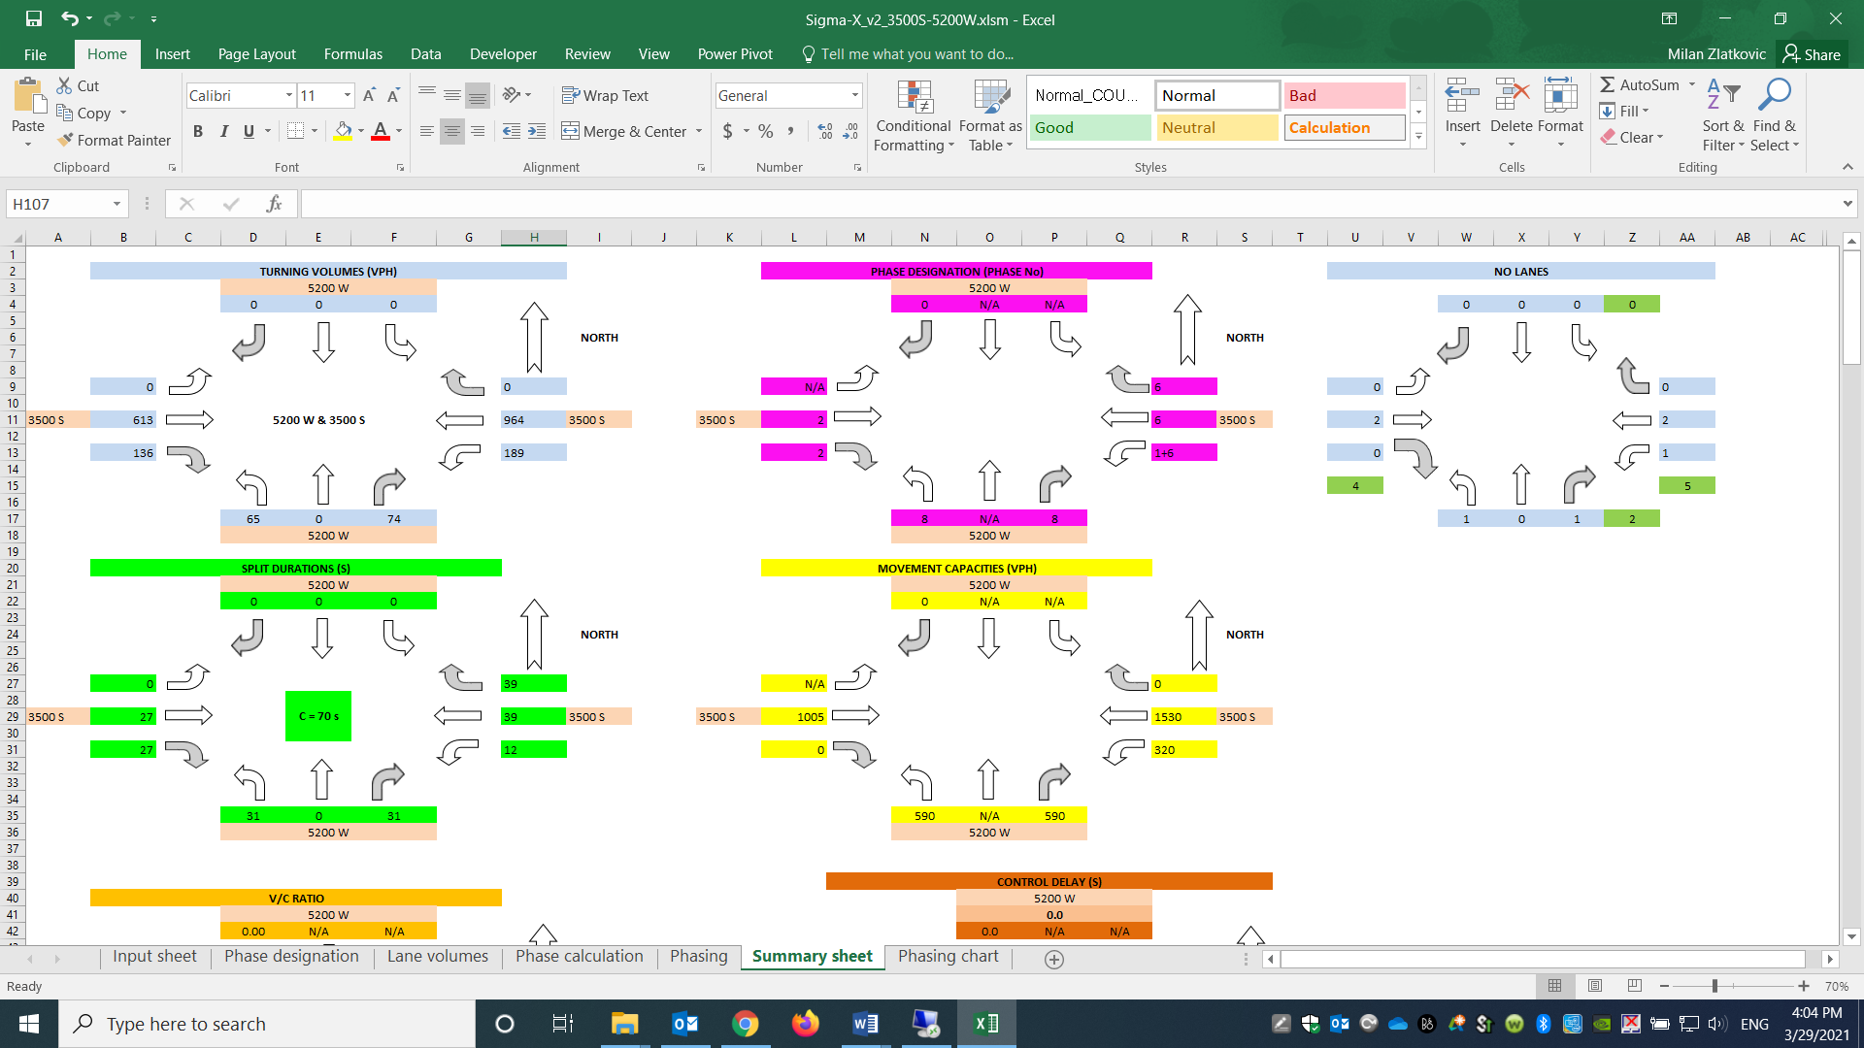

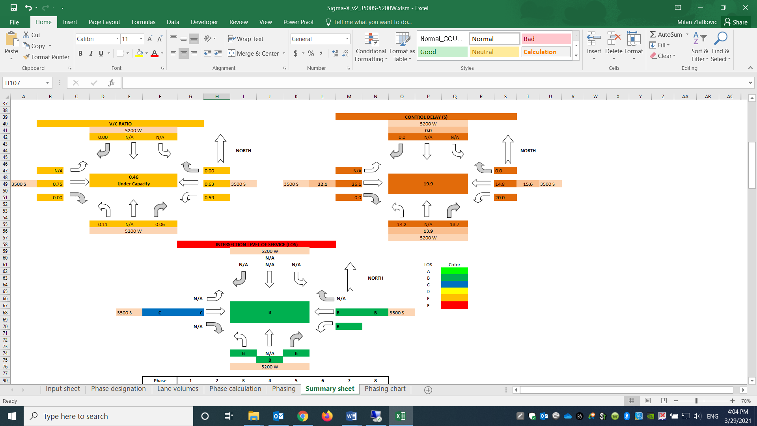

**Figure E2-3. Sigma-X Results for 5200 W and 3500 S Intersection**

Sigma-X calculates the cycle length to 70 s, and assigns WB left turns as protected + permitted, and NB left turns as permitted only. The average intersection delay is 19.9 s/veh, and the LOS is B.

The cycle optimization calculates the optimal cycle to be 110 s, the total intersection delay of 15.9 s/veh, and the intersection LOS B.